**Exploratory data analysis of Hotel Bookings to reduce cancellation rates**

**Business Problem**

In recent years, City Hotel and Resort Hotel have seen high cancellation rates. Each hotel is facing issues such as fewer revenue and less than ideal hotel room use. The primary goal is to lower the cancellation rates in both hotels in order to increase their efficiency in generating revenue.

What to determine :

* **Finding the most predictive features of the data and filter it so it will enhance the predictive power of the analytics model.**
* **Variables that affect hotel reservation cancellations**
* **How to make hotel reservation cancellations better**
* **How will hotels be assisted in making pricing and promotional decisions**

**Hypothesis :**

* **More cancellations occur when prices are higher**
* **When there is a longer waiting list, customers tend to cancel more frequently**
* **The majority of clients are coming from online travel agents to make their reservations**

**Analysis and Findings**

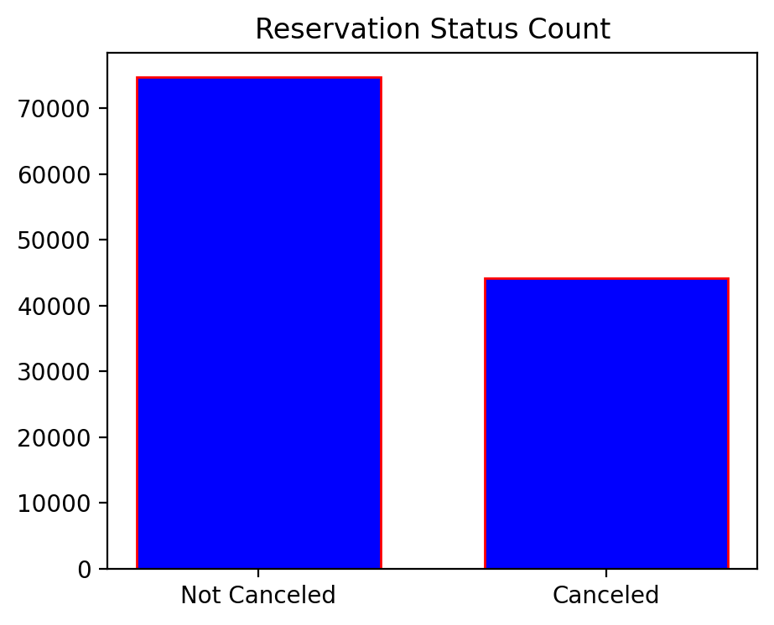

From the bar graph , it can be observed that while a significant number of reservations have not been cancelled , there are still 37% of clients who cancelled.

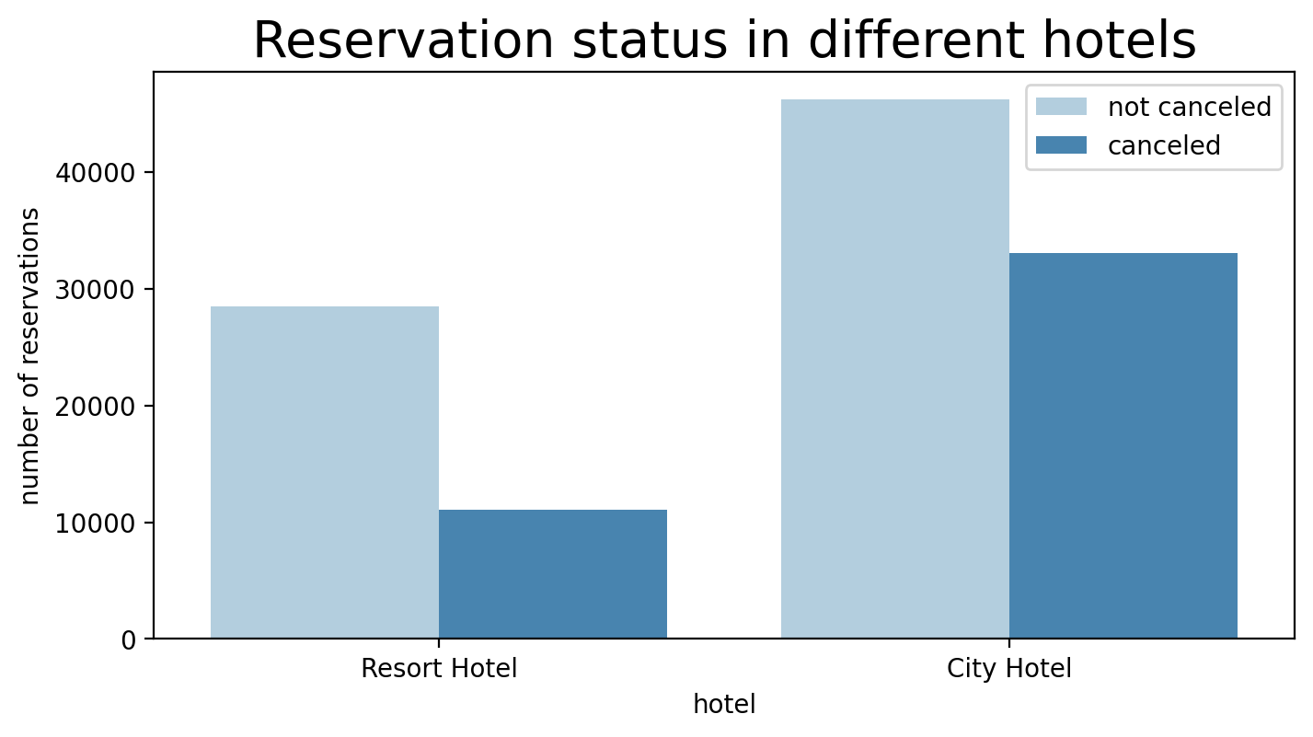

In comparison to resort hotels, city hotels have more bookings. It is possible that resort hotels are more expensive than those in cities.

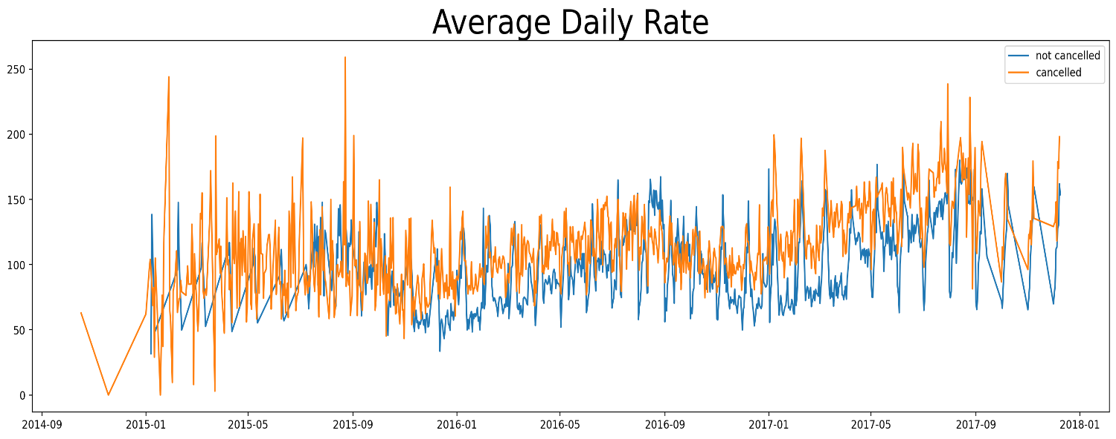

The line graph above shows that on certain days, the average daily rate for a city hotel is less than that of a resort hotel, and on other days, it is even less. The weekends and holidays may see a rise in resort hotel raises.

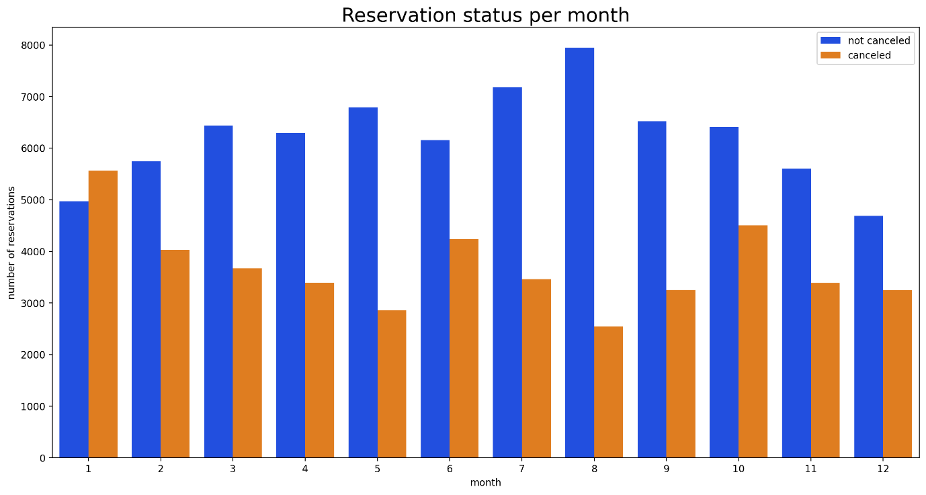

The grouped bar chart above shows the months with the highest and the lowest reservation levels according to reservation status. It can be observed that the minimum cancellations are in August and maximum cancellations are in January.

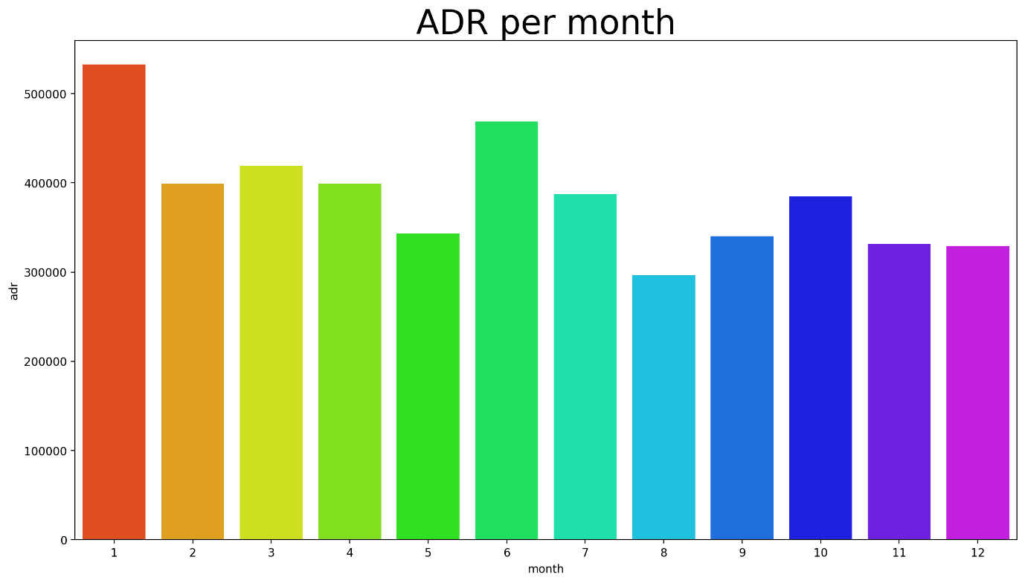

This bar graph demonstrates that cancellations are most common when prices are greatest and are least common when prices are lowest. ADR is the highest in January and lowest in August. Hence, the cost of the accommodation is solely responsible for cancellation.

It proves the hypothesis that higher ADR leads to most cancellations and lower ADR leads to less cancellations.

Now , let’s see which country has the highest reservation cancelled. We have considered the top 10 countries with most number of cancellations. The top country is Portugal with the highest number of cancellations.

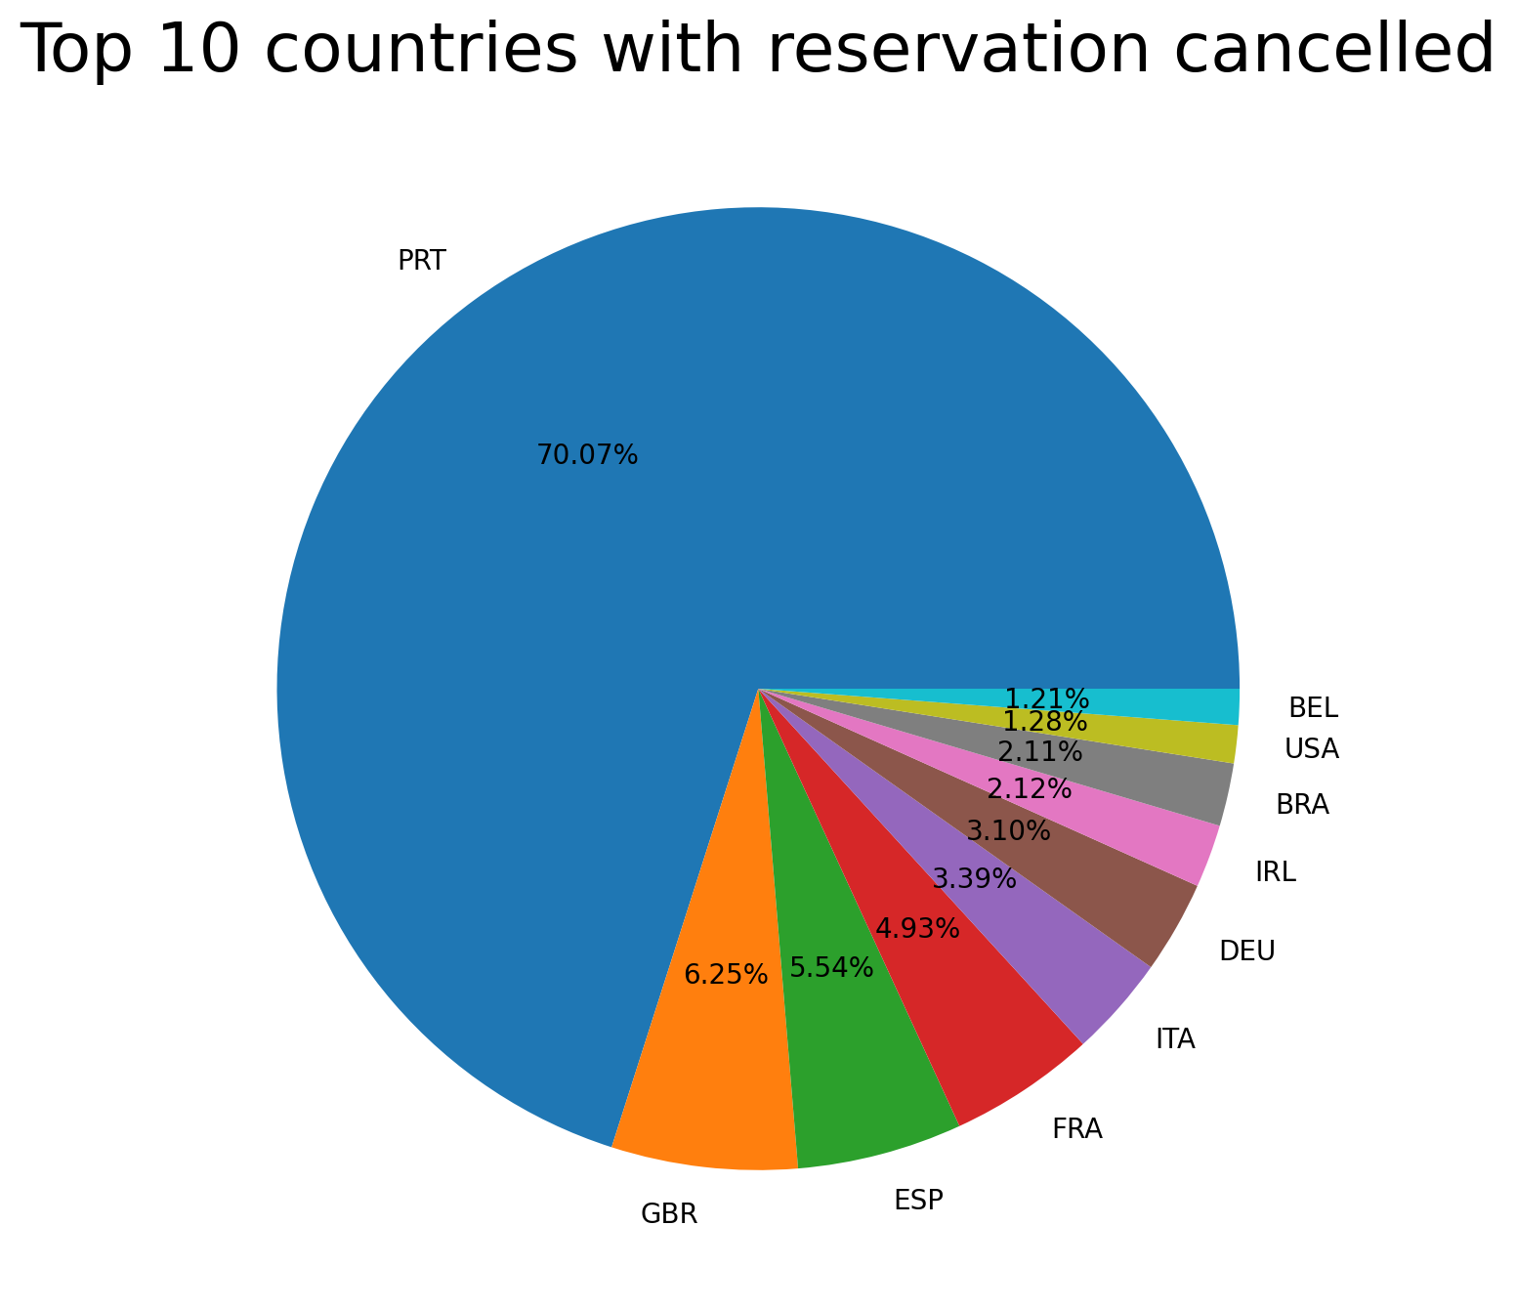

We also checked the area from where the guests are visiting the hotels and making reservations. The list includes Direct or groups, online or offline travel agents. We found that around 46% of the clients come from online travel agencies, whereas 27% come from groups. Only 4% of clients book hotels directly by visiting them and making reservations.

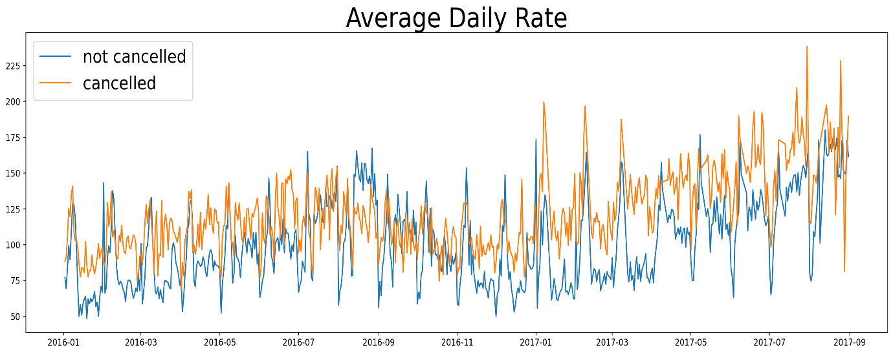

As seen in the graph, reservations are cancelled when the average daily rate is higher than when it is not cancelled. It clearly proves all the above analysis, that the higher price leads to higher cancellation.

**Suggestions**

1. Cancellation rates rise as per price . In order to prevent cancellations of reservations, hotels could work on their pricing strategies and try to lower the rates for specific hotels based on locations. They can also provide some discounts to customers.
2. In the month of January, hotels can start campaigns or marketing with a reasonable amount to increase their revenue as the cancellation is highest in this month.
3. They can also increase the quality of their hotels and their services mainly in Portugal to reduce the cancellation rate.